**Short Term Trading Market Maker Manipulation Templates**

All examples are depicted in 60 minute chart perspective SSL example

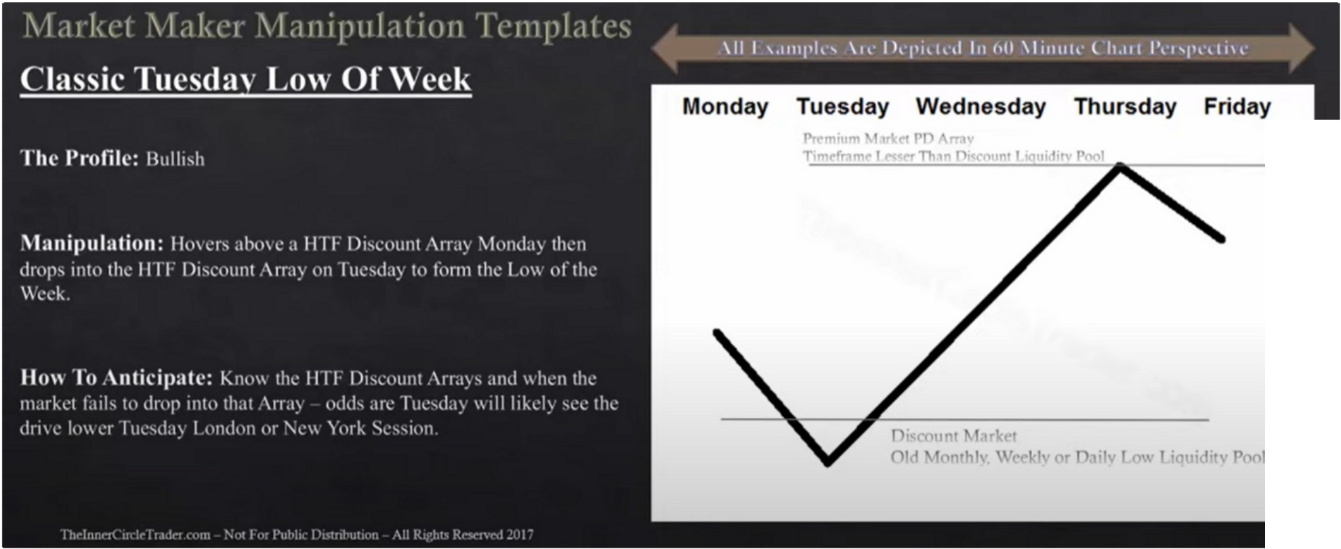

Youre going to be looking for a PD array thats lesser then the one you bought off, so buy off monthly PD array then youre going to be aiming for weekly or daily PD array. If you buy a weekly PD array youre going to be looking for a daily or 4h PD array etc etc.

Old high example

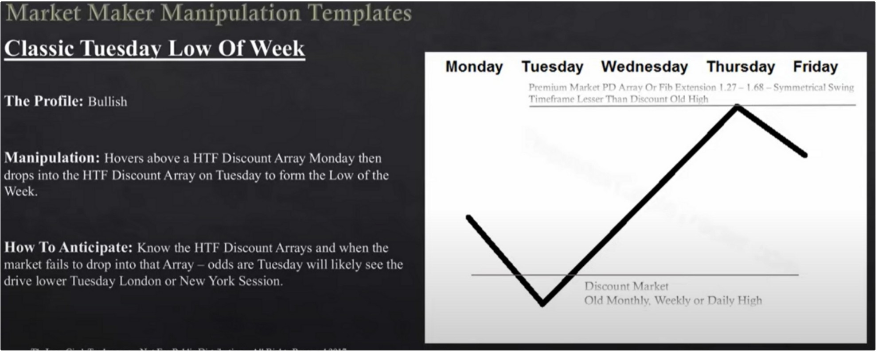

Look for a lesser PD array and with an overlapping fib, preferably a perfectly symmetrical price swing of 100%

Bullish orderblock example

3rd swing grade you generally don't get stop runs, but you do get bullish orderblocks in 3rd swing grade so we can use that. When we look at price swings and targets for trades we graduate it into 4 stages, 1st stage, 2nd stage takes us to equilibrium, 3rd stage or 3rd swing grade, and the 4th its the terminus thats the maximum where we expect the market to move

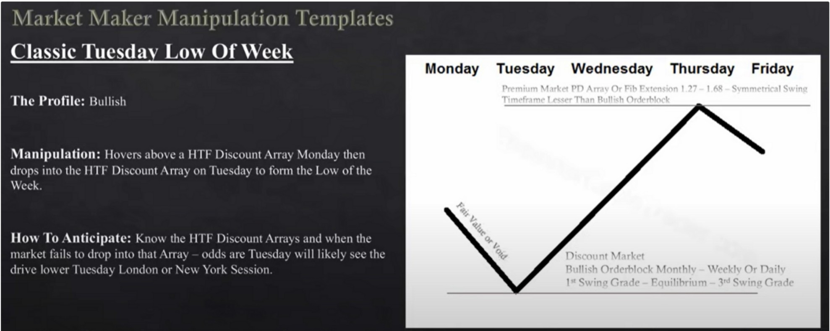

BSL example

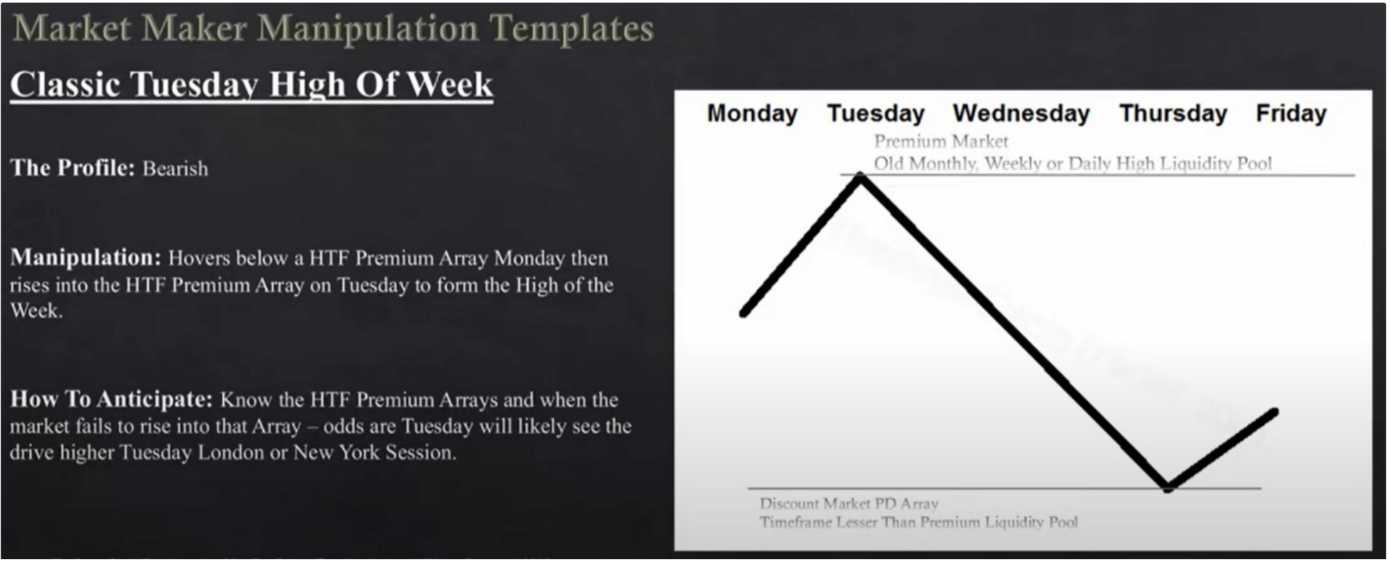

If you are trading from a daily high getting taken out, then you could target a 4h discount array, that would be your weekly range

Monthly weekly and daily give us a high probability

Old low example

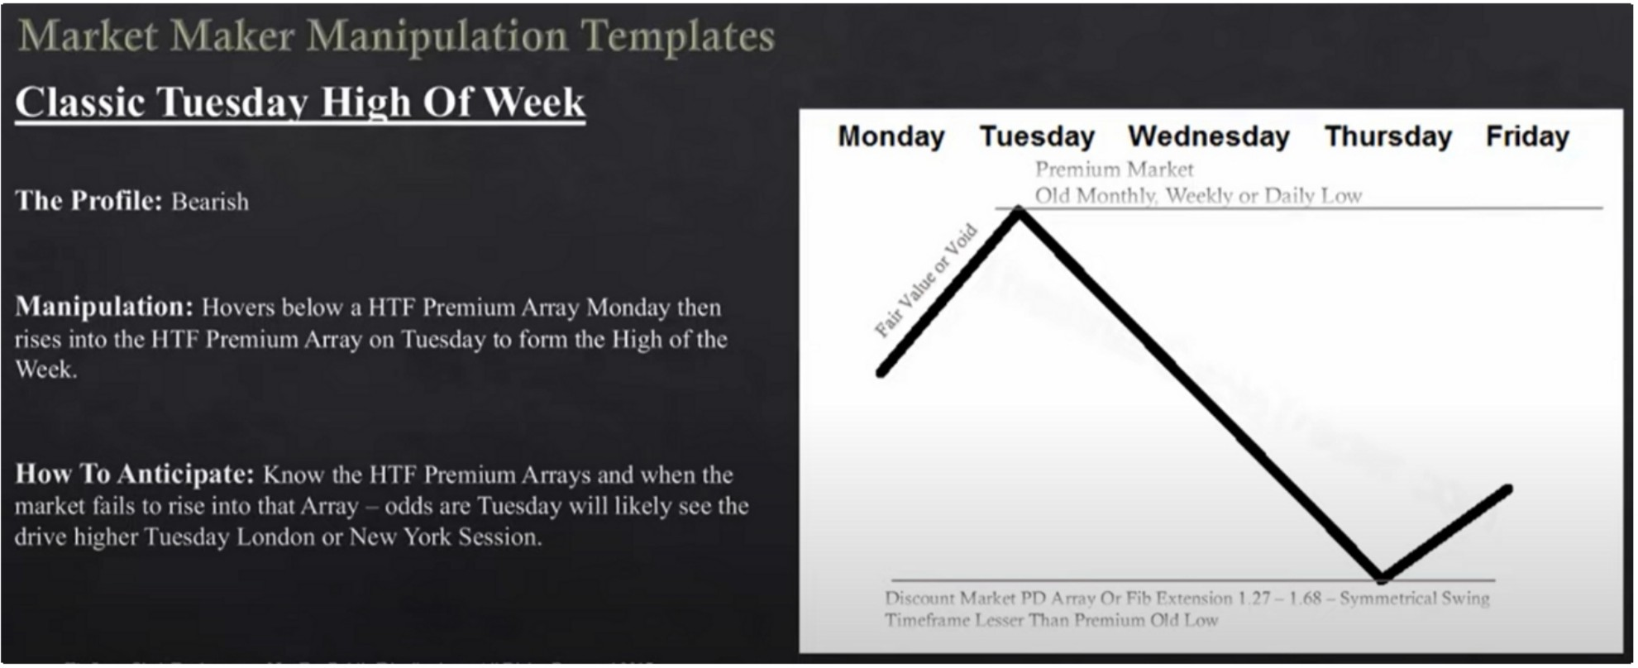

The initial move up in the beginning of the week is where you place your fib

Bearish orderblock example

It could be a 1st swing grade or at EQ or a 3rd swing grade entry

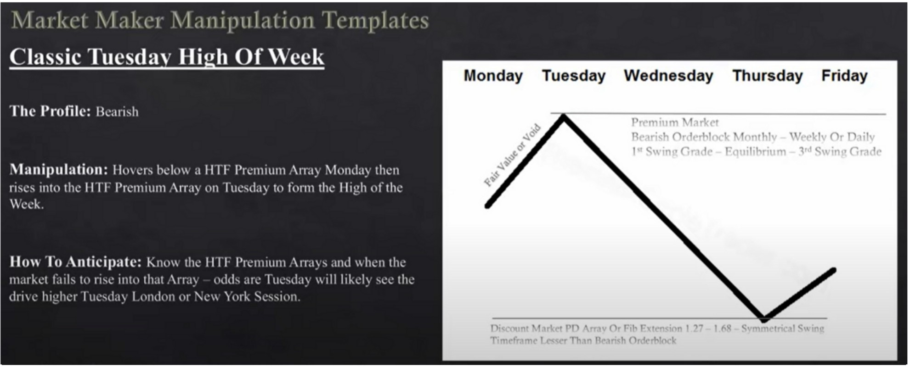

The fib has to overlap with the lesse timeframe PD array

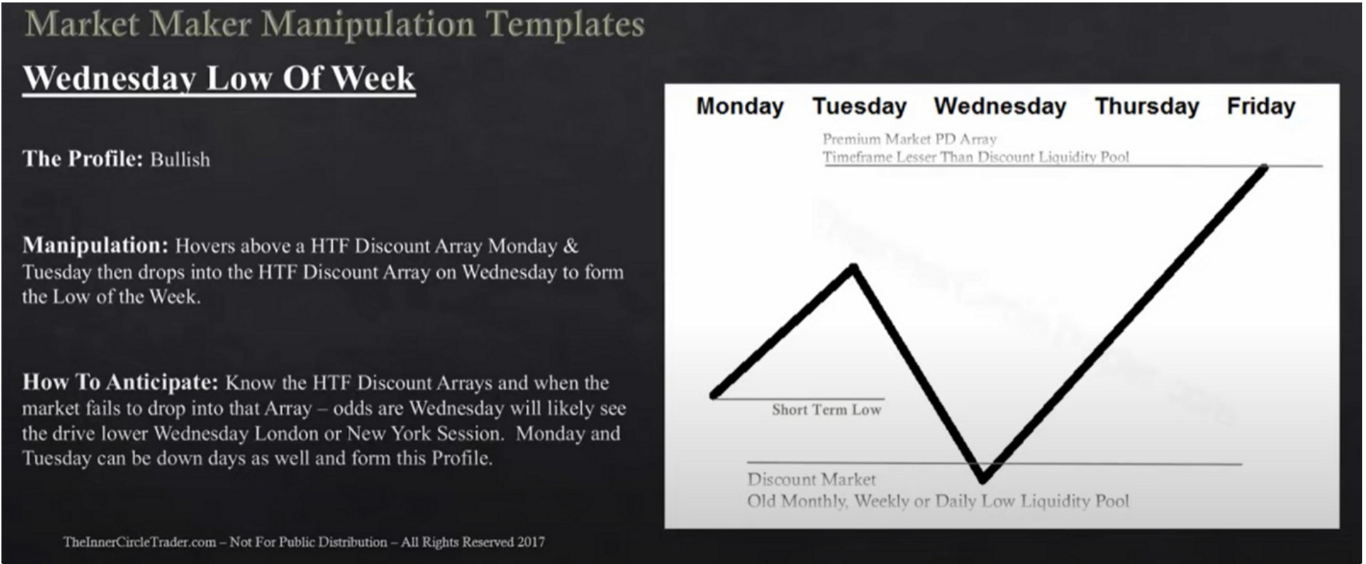Wednesday low of the week SSL example

Old high example

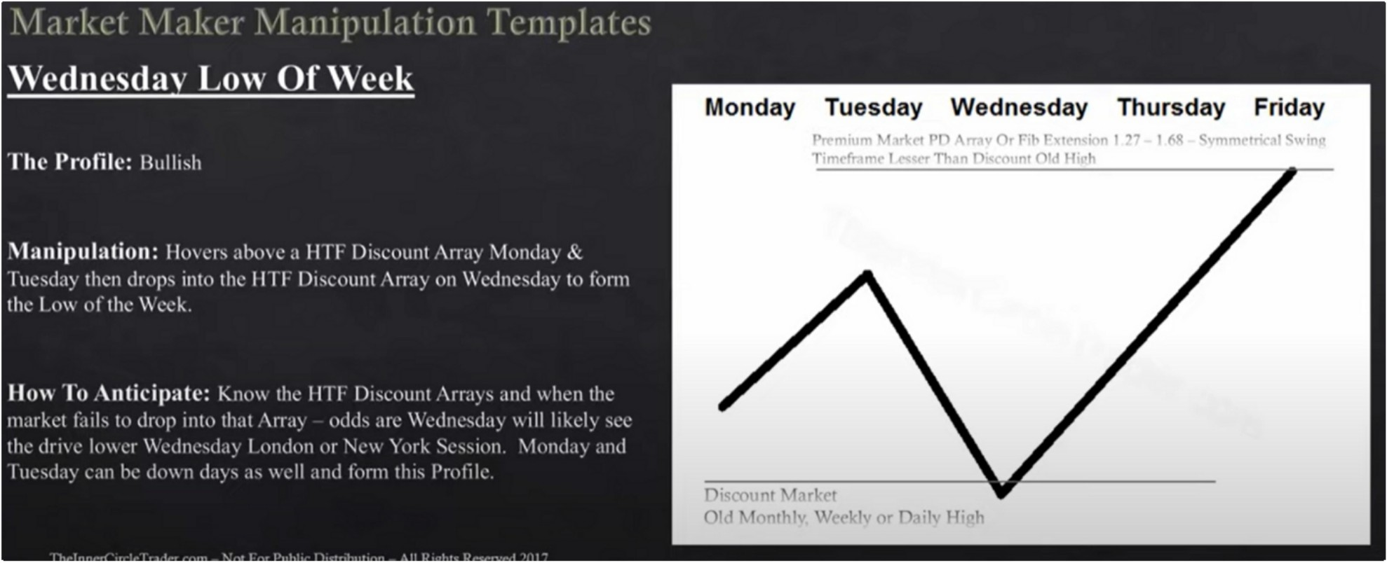

Bullish orderblock example

When we look at price swings and targets for trades we graduate it into 4 stages, 1st stage, 2nd stage takes us to equilibrium, 3rd stage or 3rd swing grade, and the 4th its the terminus thats the maximum where we expect the market to move

\l.11ht \l.1kL·1 \l,111ipt1l.1tio11 lr111pl.1trs

**Wcdncsdav Low Of Weck**

Pr 1 l"1' PP ;\ 1 *('\,* F, r t I "'7 I ,.q C::\ r I C:: {'

T1 ·"t I Th 1n null h n, ' .._, l

**The Profile:** llulh,h

**\lanipulalion:** llll,,r, ahll,, a II IT lli,cllunt .·\rra \h,nda, & IUl.·,day thL'll dflllh into thL· **1111** 1>1,L·nunt .-\rr;i on \\"cdn1..·,day to t ,rm llh..· Io\\ \lflh1..· \\"l·\,.·1-...

**IIO\\ To .\nlidpak:** 1'11<1\\ tlic 1111·llrsc·.,,11,1 .\rr.l\, .111d II lien the

111;1rl-..1..·t L11I, 1\1 d1'l1p 111{11 th.it .\n.i:,. l1dd..., ;111..· \\·1.:d111..·,d;i:,. \\1ll l1l...,.:l:,. *,1.:\.·*

tli1..· dr1\1..' l,1\\1.T \\1..·d111..·,d.1: I ,111dn11 ,1r \1..'\\ Y,1rJ.. \•n.,_·,,11111 \1,111d,1:,. ;111d

I t11..·. ,d.1: 1.·,111 h1..· d11\\ 11 d,1:-. ,1-. "'-·11 .1 nd l11n11 th 1, Pr111·1 k·

The fair value/void note on the example is what you use your fib on, that leg Wednesday high of the week

BSL example

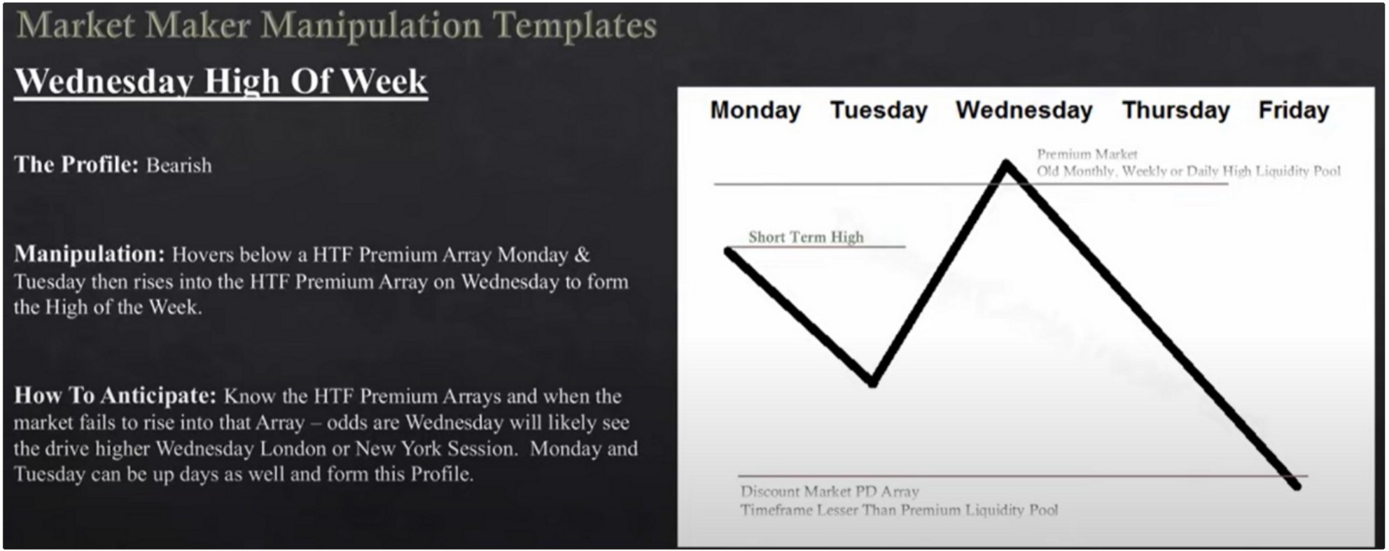

Old low example

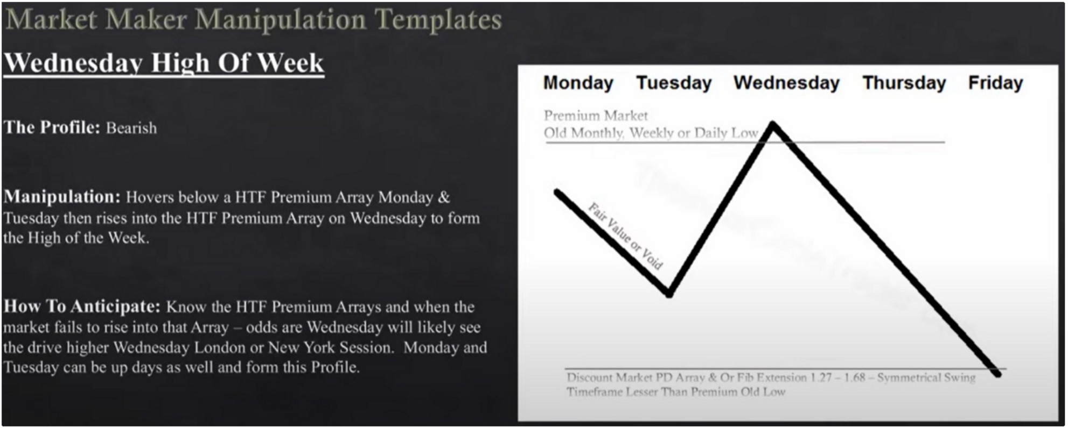

Bearish orderblock example

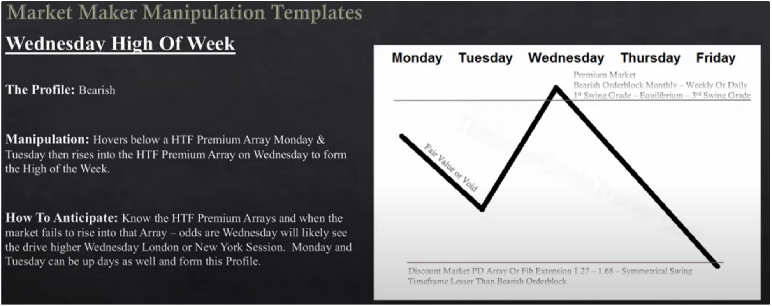

Consolidation thursday reversal bullish

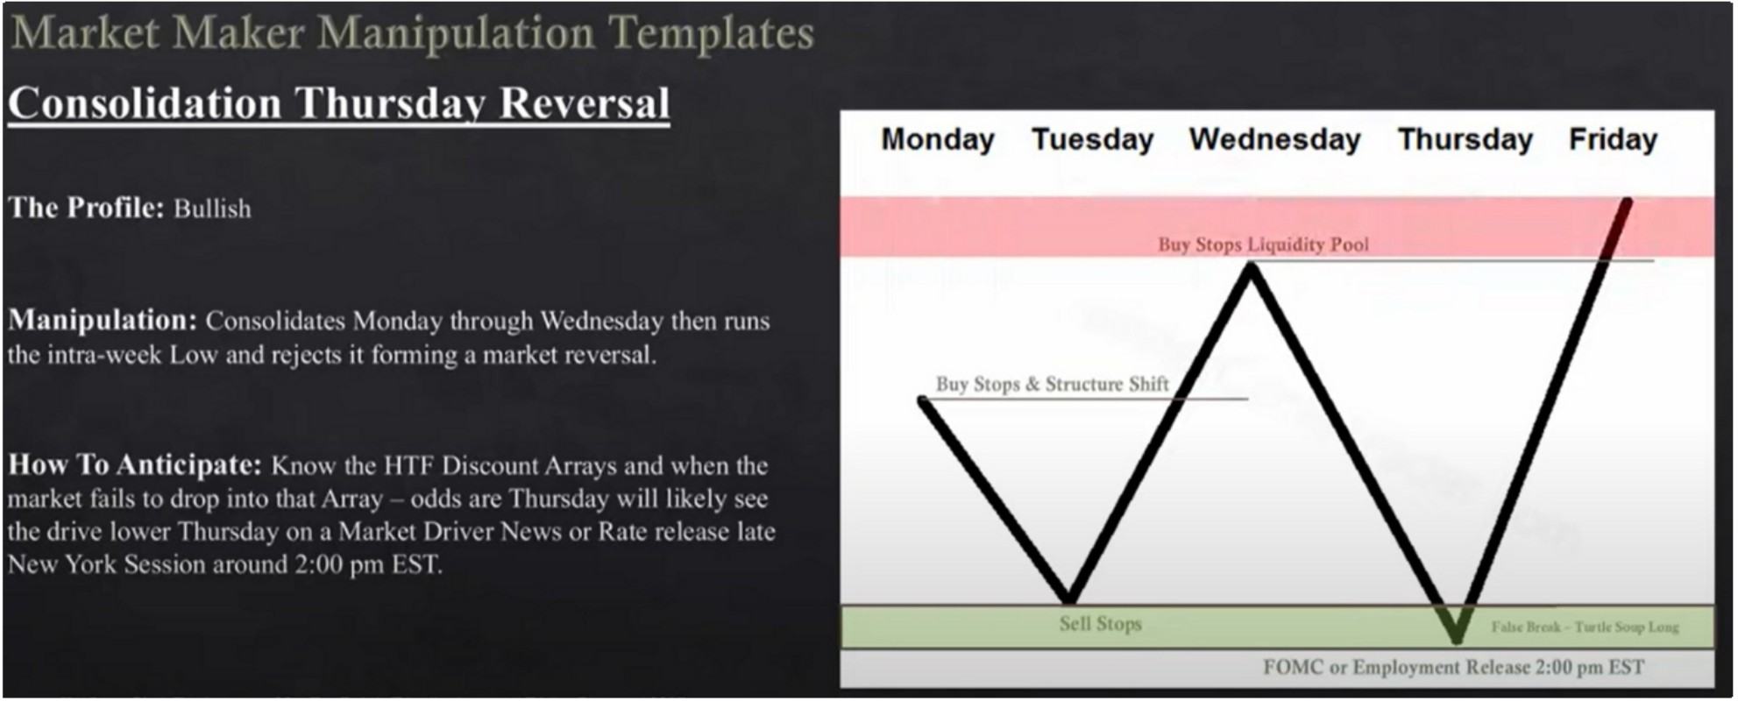We look for sell stops to get taken in a bullish market, turtle soup long Generally happens with news on thursday

The one shot one kill setup would be on thursday buying below the low

Use a small position on FOMC

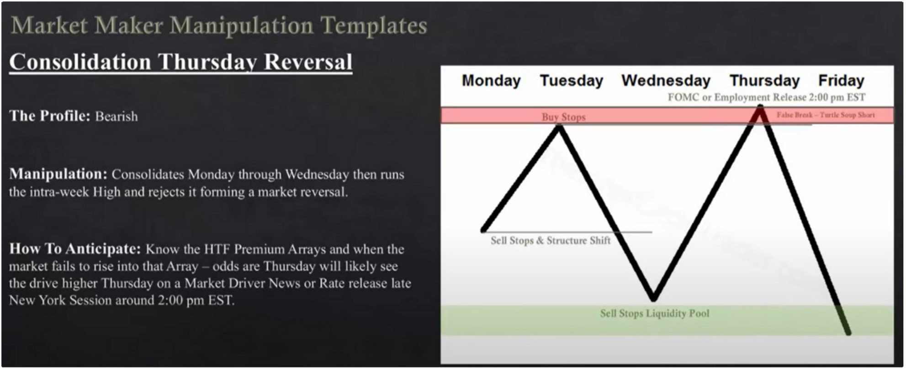Consolidation thursday reversal bearish Turtle soup short

Consolidation midweek rally bullish

High or medium impact news on wednesday, either during london or new york

The short term high can also be on monday, and then trade down on tuesday and maybe even wednesday

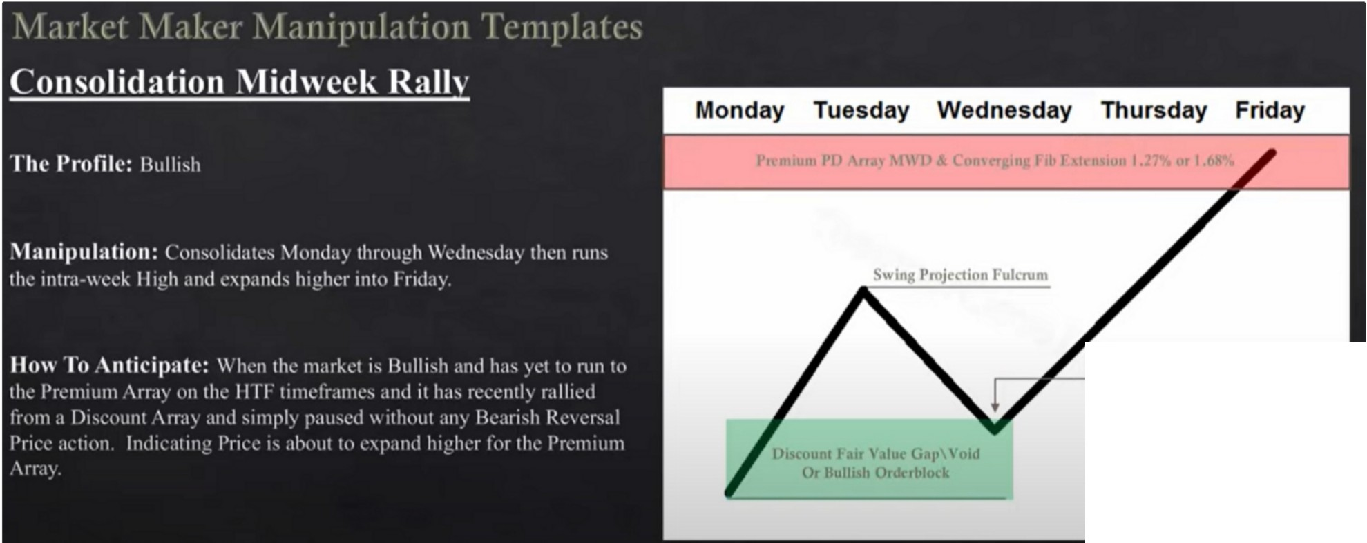

**High or l\1cdium JmpaC1 New**

Swing projection fulcrum is the highest high at which the market starts to retrace from, thats where you use your swing projection

We dont just look for the fibs, we look for it to overlap with a lesser timeframe PD array

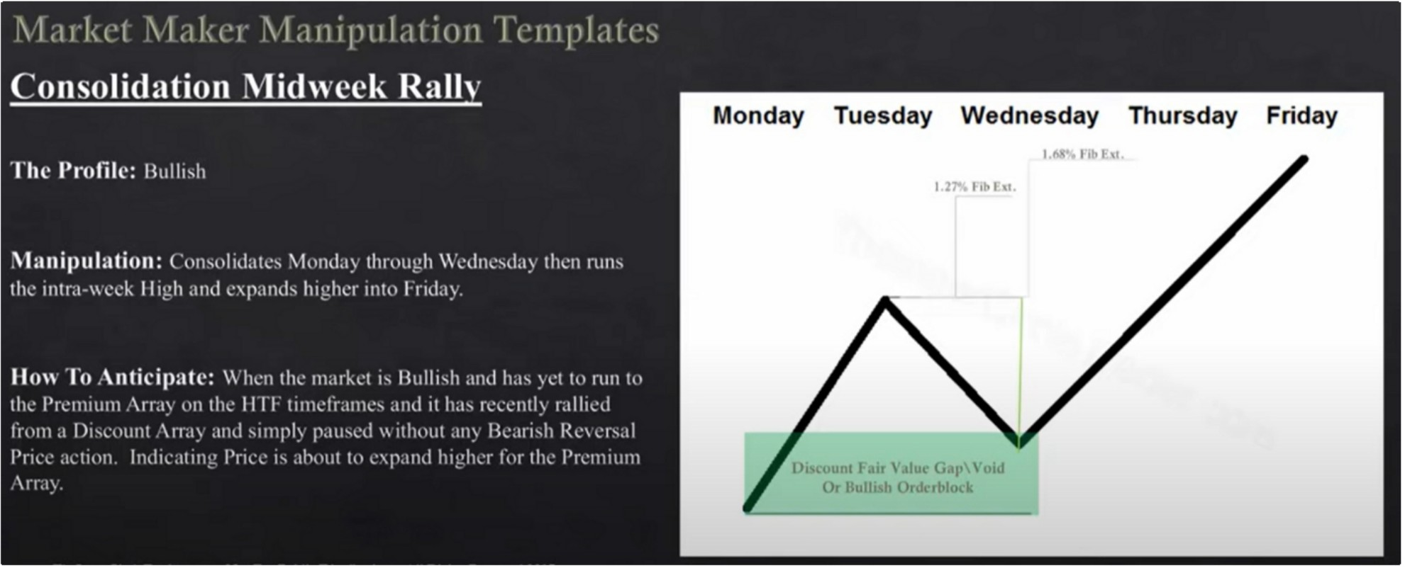

The fib overlap levels are based on the timeframe we enter on, we look for lower timeframe to look for a premium array which the fib overlaps with, when we get that thats a high confluence target where the algo wants to trade to

Consolidation midweek decline bearish

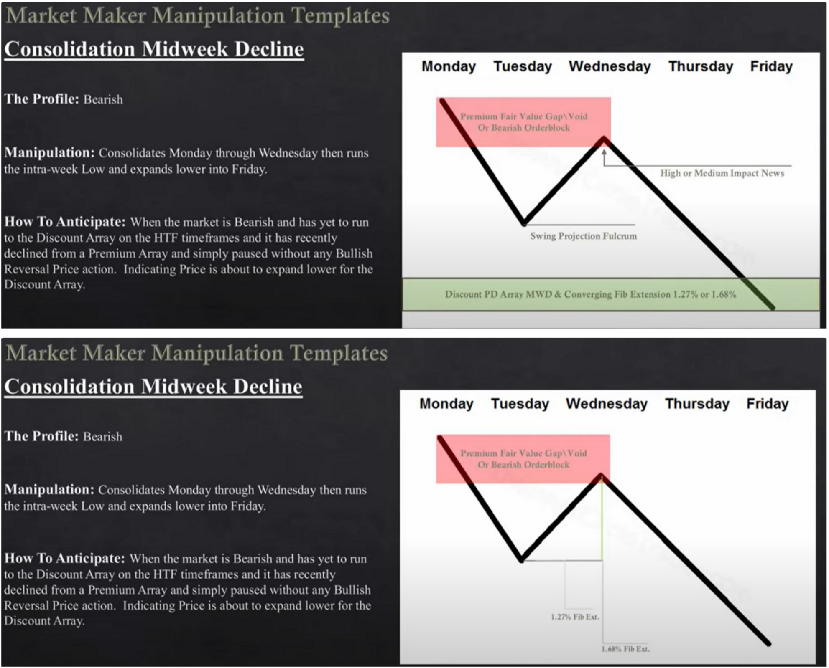

Seek and destroy bullish friday

Low probability profile, you want to demo this or be on the sidelines for experience

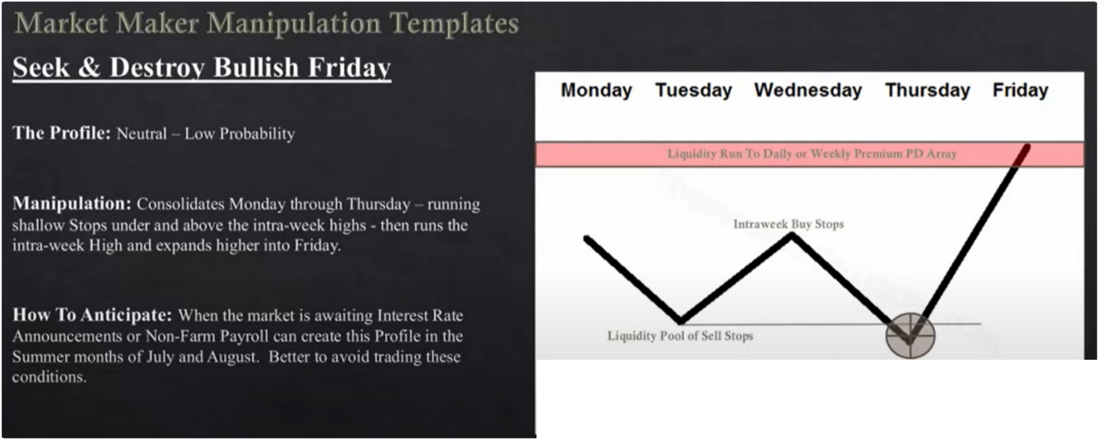

**lligh or Mrdium Jmp;u;t** ·c" \

**nti"ipatc Sdl S1op Raid**

Were looking for a speedy move

This market profile can also happen in a bearish market enviroment, if the market trades down below a low but fails to go any lower we can have a high impact news event that sends us higher

This is the hardest market profile to trade, if you see the market consolidating or taking buy stops and sell stops troughout to week its better to sit on your hands and not trade. It can blow trough your stop loss.

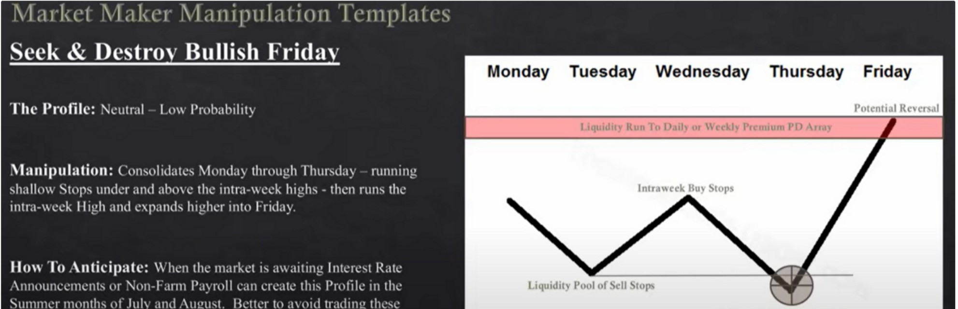

Once we trade to the weekly or daily PD array we will be looking for a potential reversal, thats where we can get involved

Seek and destroy bearish friday

Wednesday weekly reversal bullish

Its not the same as wednesday low of the week, its slightly different

Its generally that we see this on **HTF** basis, so we'll see a weekly or monthly support level get taken out with high or medium impact news. It usually comes into a MWD (monthly week daily) PD array below the low that got ran

Wednesday weekly reversal bearish

This is the playbook for the one shot one kills Weekly ranges will be 1 of these templates

Youre already going to know if were going to be bullish or bearish based on the info from january studies. If we already know were going to be bullish then we look at all the bullish profiles, and look at all the manipulation that takes place, how does smart money maniuplate the market.

We dont demand a perfect entry on the low or high of tuesday, if we know the weekly range we can still have an one shot one kill on thursday or even friday

Look for characteristics that these market profiles will line up Homework, look at 1 pair and look at how the manipulation took place